12)Design DFA using simulator to accept the input string “a” ,”ac”,and ”bac”.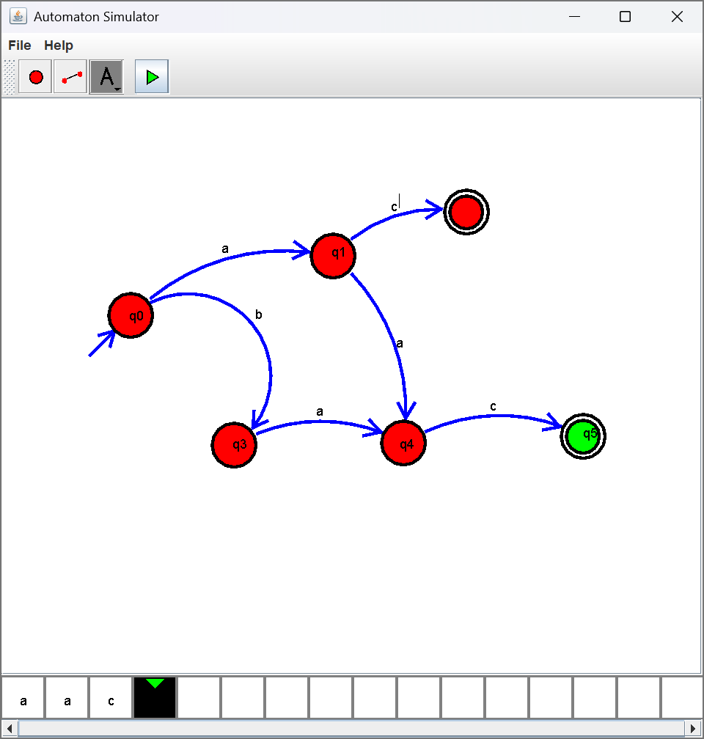
13)Design PDA using simulator to accept the input string aabb
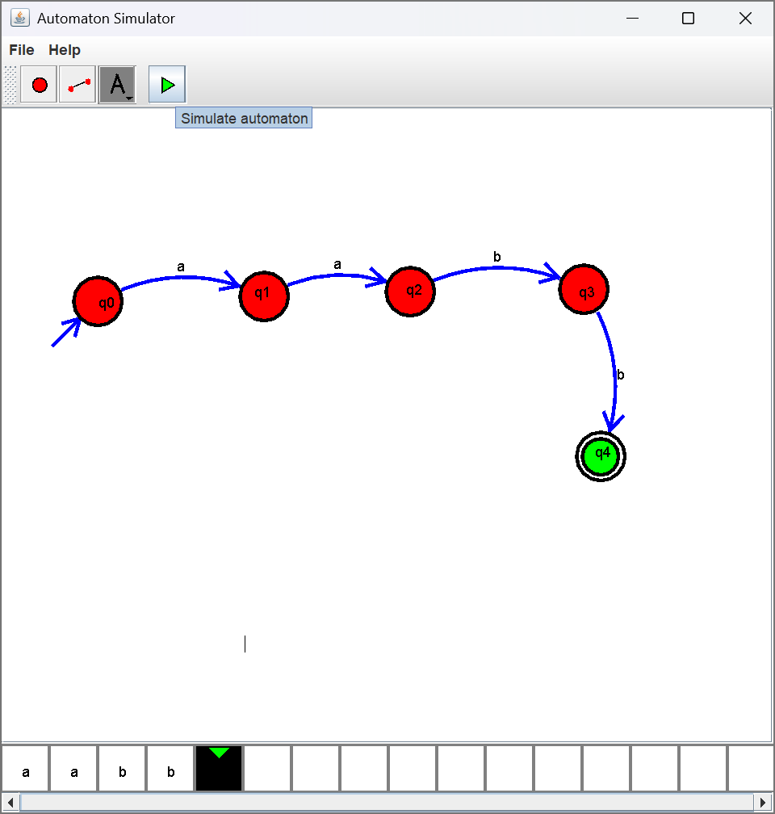
14)Design PDA using simulator to accept the input string anb2n
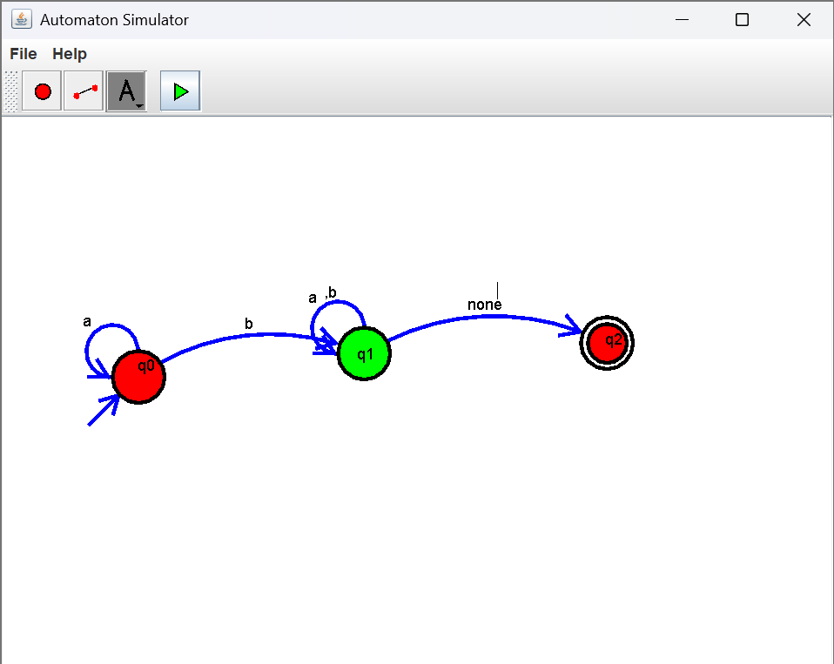
15)Design TM using simulator to accept the input string anbn
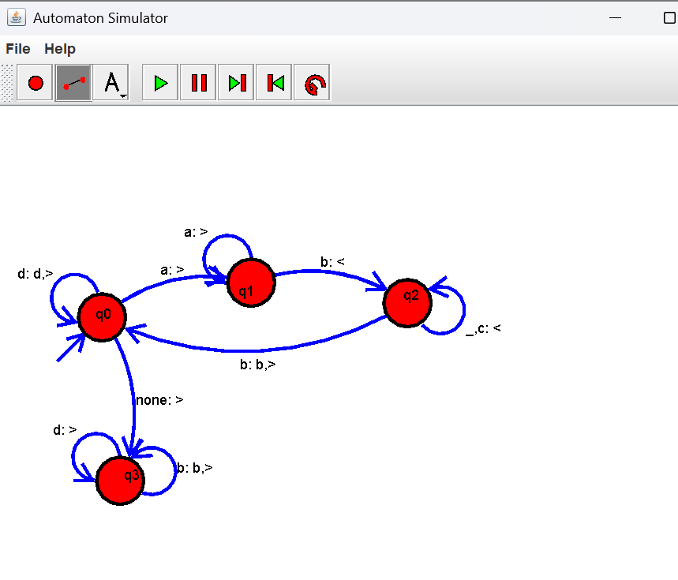
16)Design TM using simulator to accept the input string anb2n
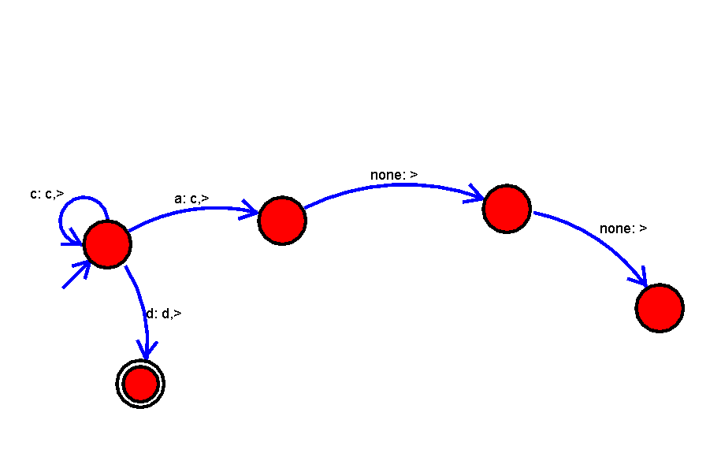
17) Design TM using simulator to accept the input string Palindrome ababa
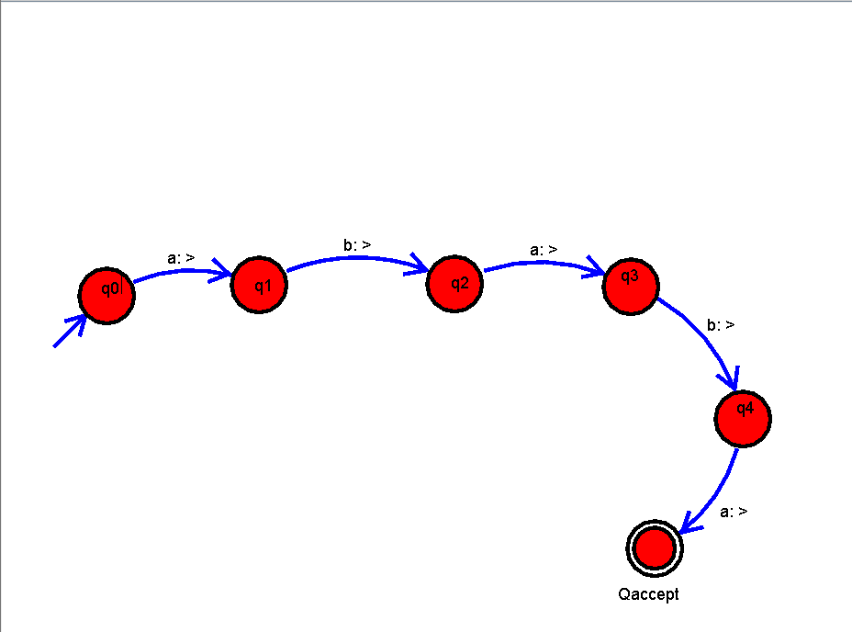
19) Design TM using simulator to perform addition of ‘aa’ and ‘aaa’
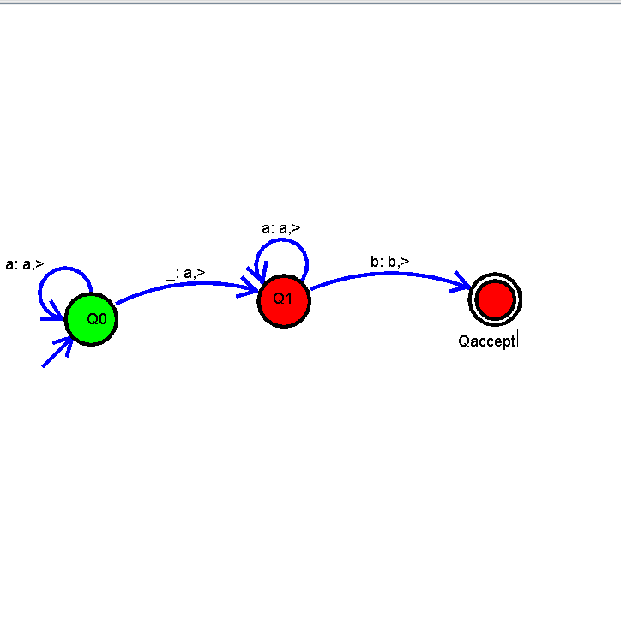
21) Design DFA using simulator to accept even number of a’s.
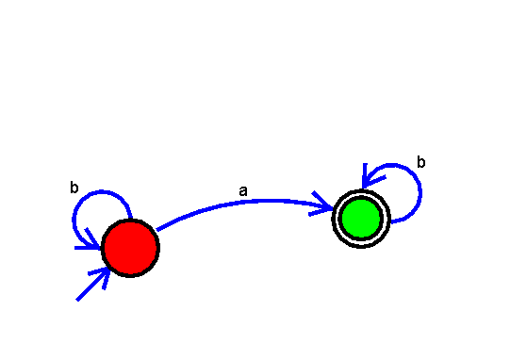
22)Design DFA using simulator to accept odd number of a’s
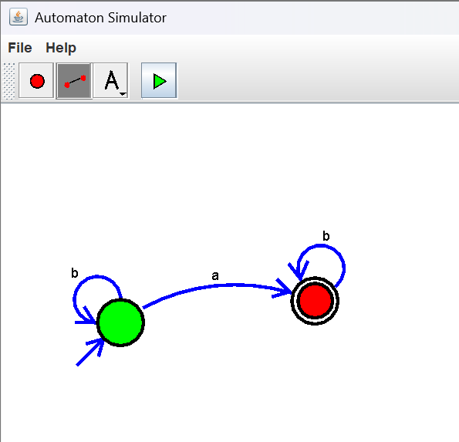
23.design DFA using simulator to accept string having “ab” as substring over the set{a,b}
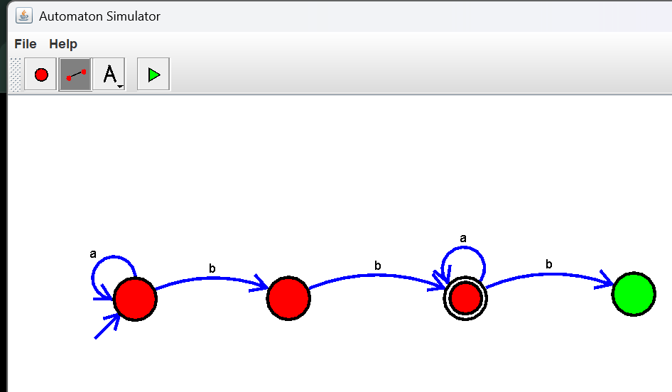
24.Design DFA using simulator to accept the string having ‘ab’ as substring over the set
{a,b}
